Physical Education
Unit 4: Outcome 2
A written report that will draw on the personal experiences recorded in the folio to design a six-week training program for a given Case Study.

Jonah is an 18-year old boy with a BMI of 24, and no known physical impairments. He plays Ultimate Frisbee. The competition Frisbee game consists of 4 x 15min quarters (including time outs) on a Saturday afternoon. He has played for 5 years. Jonah has Frisbee training twice a week.

Jonah has decided to try out for the Open age state team. A state representative official has identified Jonah as a possible candidate but has suggested to increase his chances Jonah should improve his aerobic power and muscular power of his legs.

Jonah has asked you to design a six-week training program leading up to the tryouts.
Using your knowledge of correct training principles and methods, design a six-week training program for Jonah based on the following commitments:
- Jonah is prepared to commit up to six training sessions per week
- You must utilise at least two different training methods
- You must demonstrate the correct application of training principles
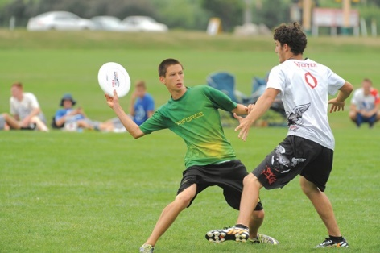

Physical Education
Unit 4: Outcome 2
A written report that will draw on the personal experiences recorded in the folio to design a six-week training program for a given Case Study.

Sally is a 17-year old girl with a BMI of 29, and no known physical impairments. She has consistently participated in a continuous running program with her sister twice per week for the four months leading up to her school’s Athletics Carnival.
Sally won the 400m track event at the carnival in a time of 83 seconds; she has been selected to represent her school at the upcoming interschool athletics carnival in six weeks. Sally is confident she could win the event if she could cut her time for the 400m to 75 seconds.
Sally has asked you to design a six-week training program leading up to the event to help her achieve her target time.
Using your knowledge of correct training principles and methods, design a six-week training program for Sally based on the following commitments:
- Sally is prepared to commit up to six training sessions per week
- You must utilise at least two different training methods
- You must demonstrate the correct application of training principles (emphasis on Frequency, Progression & Intensity)

Physical Education 2020
Unit 4: Outcome 2
Design a six-week training program to enhance specific fitness components for a given Case Study – which will take the form of a written report.

Coby is a 34 year old VCE PE teacher, with no physical impairments. Coby is relatively active and attends her local gym 6 times a week, she has done this for the past 10 years and has a good base of fitness.
Coby lives in Melbourne and due to the outbreak of Covid 19, is living through her second lockdown. Since Monday 23rd March she has only had access to her local gym for just under a total of 3 weeks (June 22 – July 8). During this time Rachel has enjoyed ISO-baking, leading to an increase in her fat mass and unfortunately her overall fitness has declined.
Coby has decided that she needs to snap out of this detrimental routine and start training again with a new goal. Coby would like to Run 10km in under an hour (6min/ kilometre) to ensure she adheres to the Stage 4 Lockdown Restriction of Exercise is limited to a maximum of one hour, once per day and no more than five kilometres from your home. At the moment Coby is running 7min/kilometre.

Coby has asked you to design a six-week training program to help her achieve her target time and distance. She has identified that aerobic power, muscular endurance and body composition are specific fitness components that need to be enhanced to achieve this goal.

Using your knowledge of Training Programs, design a six-week training program for Coby based on the following commitments:
- Coby is prepared to commit up to six training sessions per week
- Stage 4 Lockdown restriction of: Exercise is limited to a maximum of one hour, once per day and no more than five kilometres from your home.
- You must utilise at least two different training methods, second lockdown is taking a toll on Coby’s motivation
- You must demonstrate the correct application of training principles
- Coby has access to tracks near her home to run on, she has 2 pairs of dumbbells (2kg & 5kg), resistance bands, and indoor and outdoor furniture and normal household items
- Coby is still working full time Monday - Friday

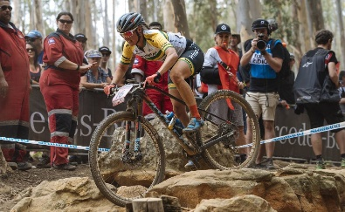
Physical Education 2021
Unit 4: Outcome 2
A written report that will draw on the personal experiences recorded in the folio to design a six-week training program for a given Case Study.

Rebecca McConnell is a 29-year old female with a BMI of 22, and no known physical impairments. She is an Australian Olympian, competing in the Women’s Mountain Bike Cross Country. The Olympic event is held on 4.1km bike course. Competitors are required to complete 7 laps, duration roughly 90-105minutes. Each lap has 8 different sections with a variety of complex features, requiring muscular power, endurance and skill from each rider. The race features a mass start and multiple laps with the first rider to complete the required 7 laps winning gold. However, riders whose time is 80 per cent slower than that of the race leader’s first lap are eliminated. Rebecca has been mountain bike riding professional for the past 9 years and has an excellent fitness base. Although due to the duration this event is aerobic based, as it is a race this is not sub-maximal and pace is important.

In the lead up to the Olympics, Rebecca completed a battery of fitness tests at the AIS in Canberra. After analysing her results, her coach Dan, has suggested Rebecca improves her aerobic power and muscular endurance of her legs to increase her medal contention.

Rebecca has asked you to design a six-week training program leading up to the Tokyo Olympics.
Using your knowledge of correct training principles and methods, design a six-week training program for Rebecca based on the following commitments:
- Rebecca is prepared to commit up to six training sessions per week
- You must utilise at least two different training methods
- You must demonstrate the correct application of training principles

